Mark Galesi

Assignment 2 Ping Trace Output

Client:

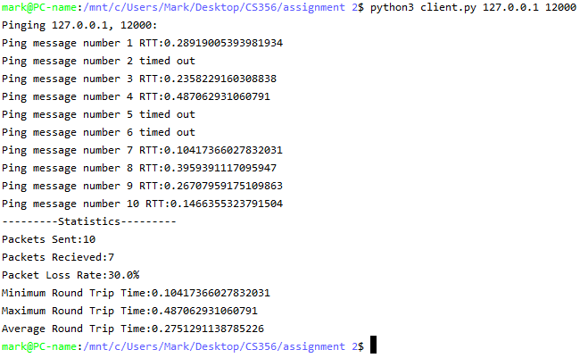

Server:

